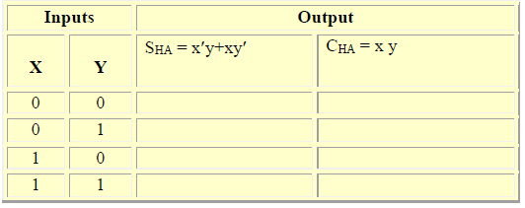

1

1

0

0

0

1

0

0

SHA = x’y + xy’

CHA = xy

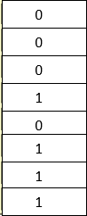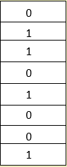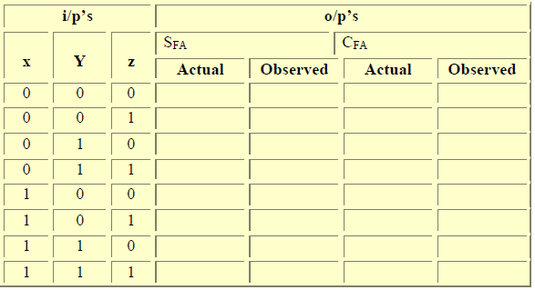

1 

1

1

1

1

1

1

1

1

0 











1 

1

1

1

0

1

1

1

1

1

0

0

0

0

0

0

0

SFA = (xy’ + x’y)(z’) + (xy’ + x’y)’(z)

Xy’z’ + x’yz’ + [ (x’+y)(x+y’)] (z)

Xy’z’ + x’yz’ + [x’y’ + xy] (z)

* xy’z’ + x’yz’ + x’y’z + xyz

CFA = xy +[ (xy’ + x’y) (z) ]

* xy + xy’z+x’yz